# **PRACTICE REPORT**

# **WEB PROGRAMMING LAB WORKS**

# **MODULE 6**

# **“PHP Based Web Application and MySQL Database (II)”**



**Assembled by:**

# **ONIC AGUSTINO**

# **L200234275**

**X**

**PROGRAM STUDI TEKNIK INFORMATIKA**

**FAKULTAS KOMUNIKASI DAN INFORMATIKA**

**UNIVERSITAS MUHAMMADIYAH SURAKARTA**

**TAHUN 2024/2025**

**PRACTICE**

1. **Experiment 1 (Godds Data Form)** 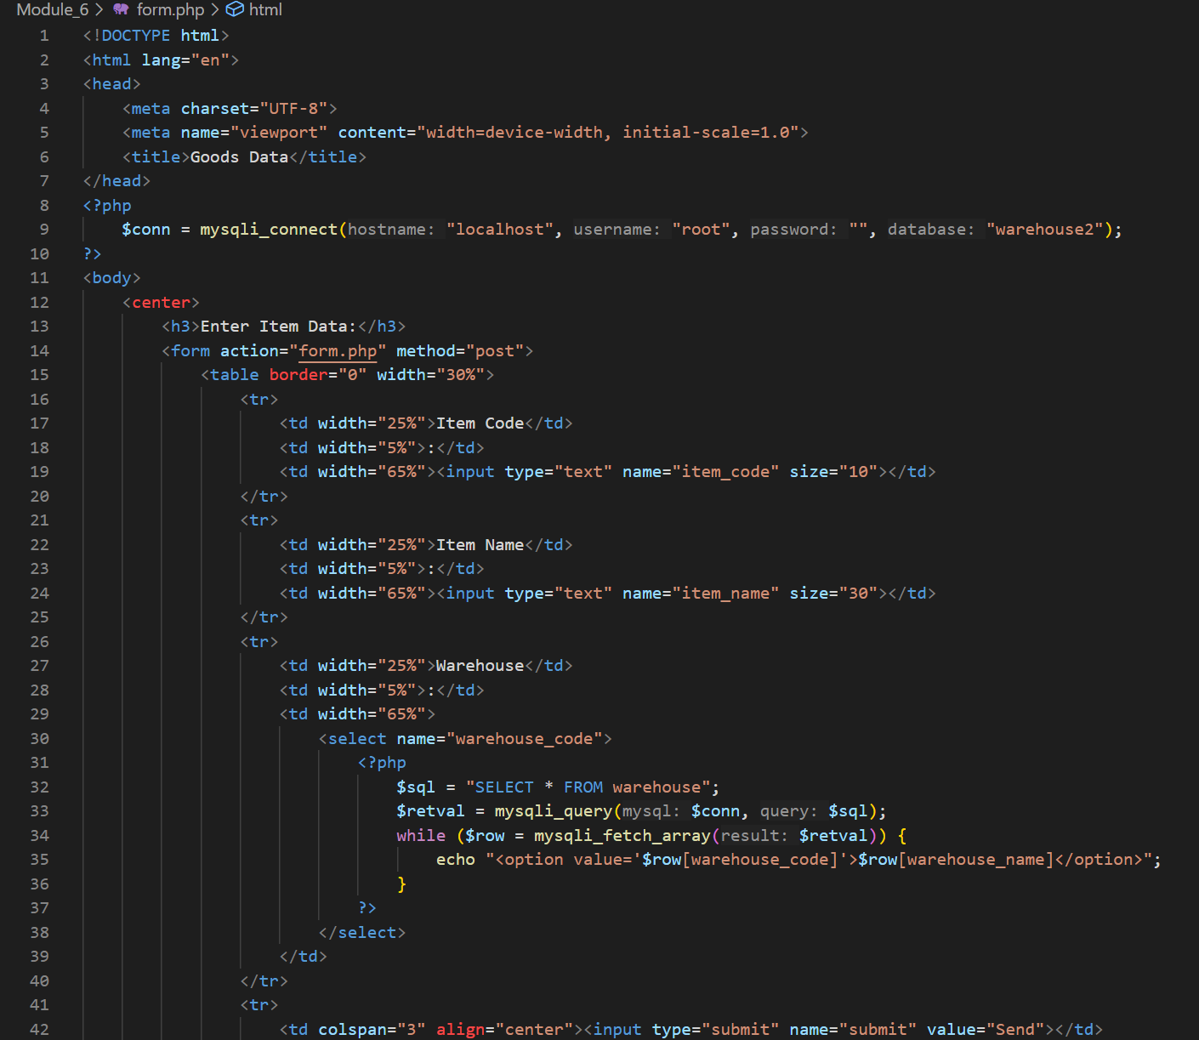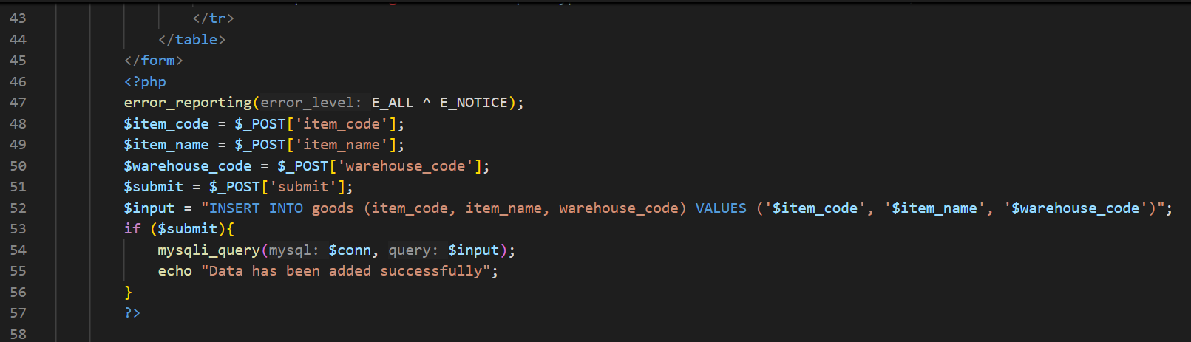

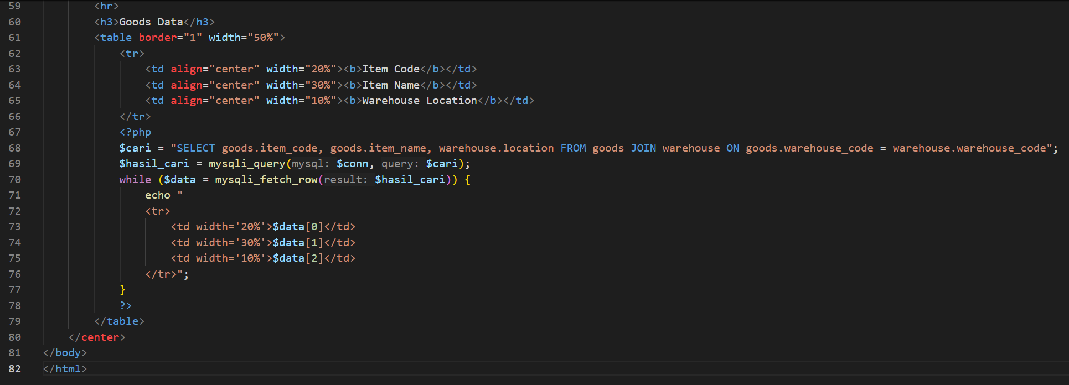

Picture 1.1 The Code.

(Explanation)

This code is an HTML page with PHP that connects to the warehouse2 database, allowing users to input goods data through a form, save it to the goods table with SQL INSERT, and then display a list of goods and their warehouse locations using SQL JOIN.

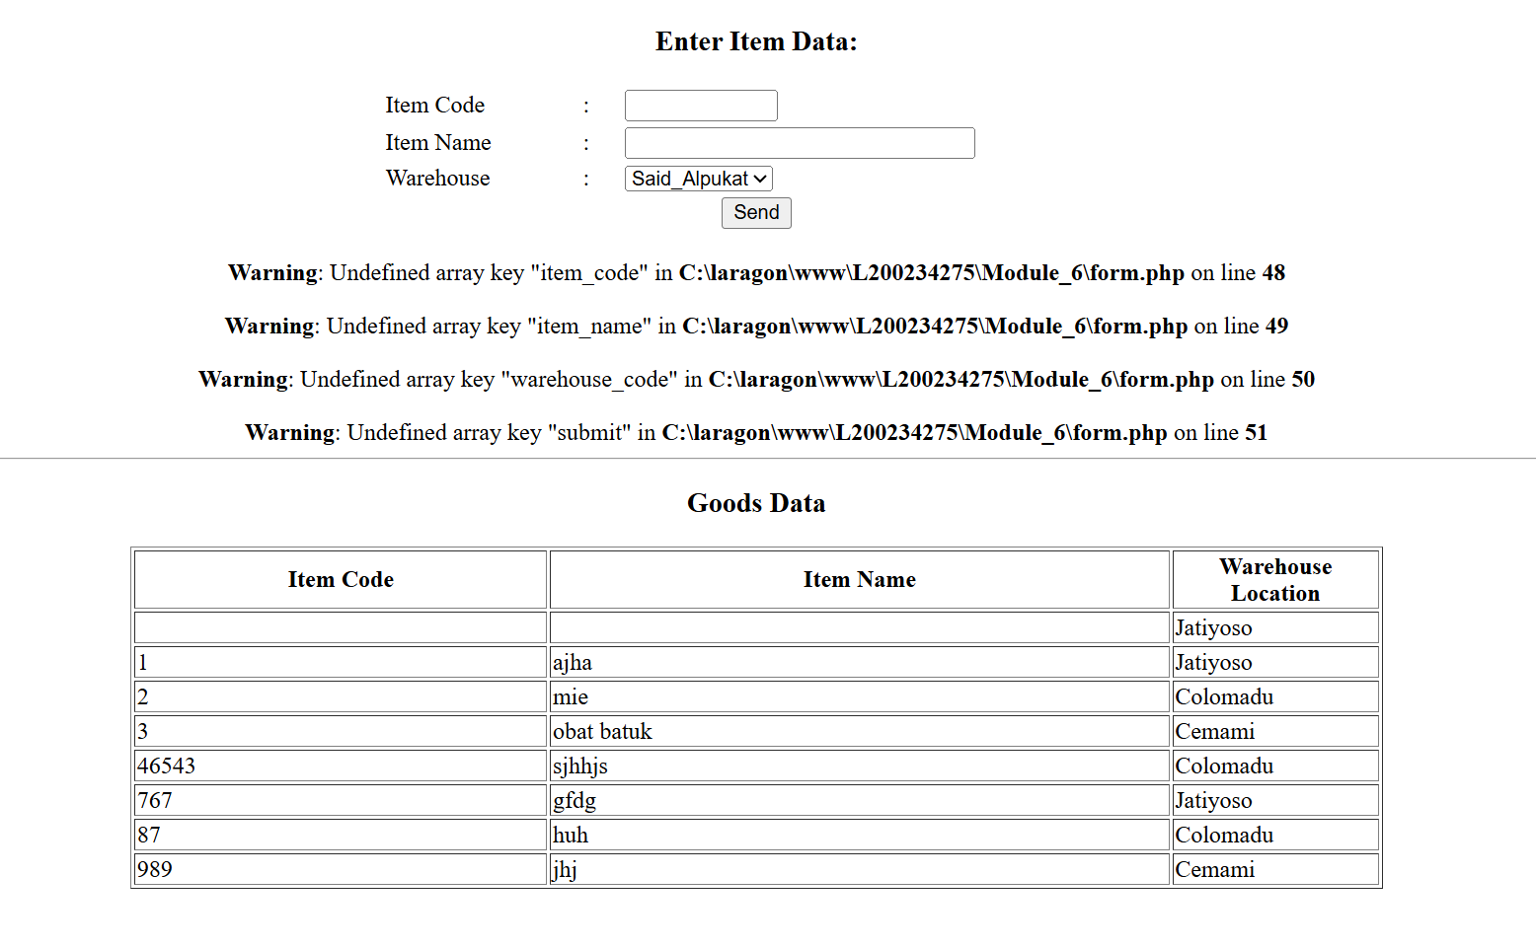

Picture 1.2 The Output.

**ASSIGNMENT**

1. **Create a book table and a book_type table contains the atributes in the ER-diagram above. After that, create a program with features for insert, update, delete and view for the two tables**
2. Form.php

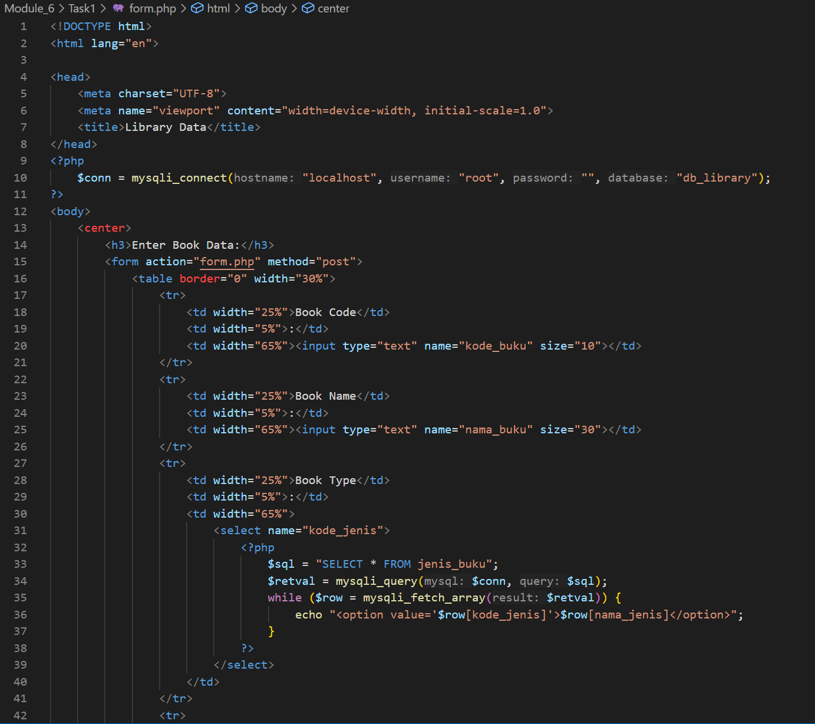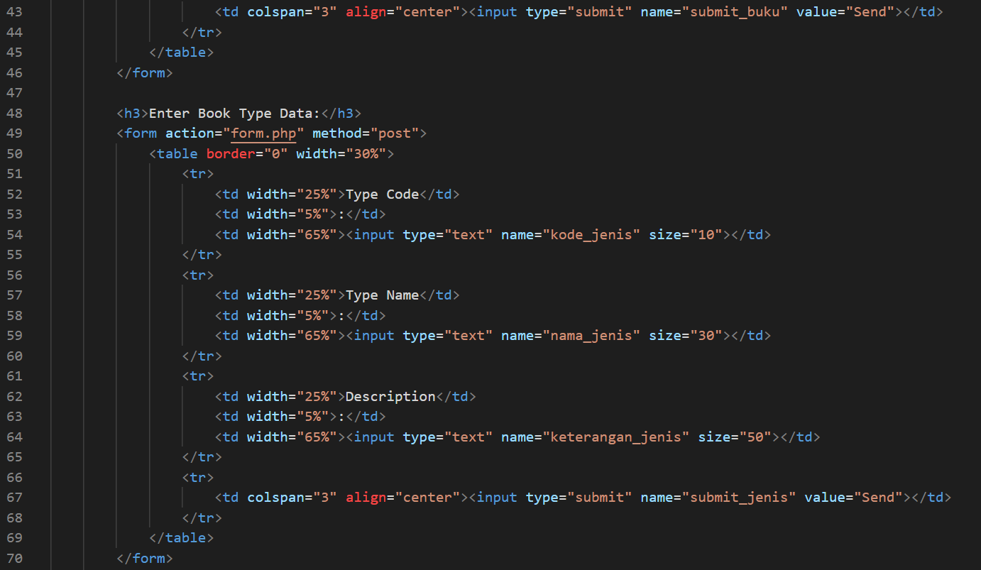

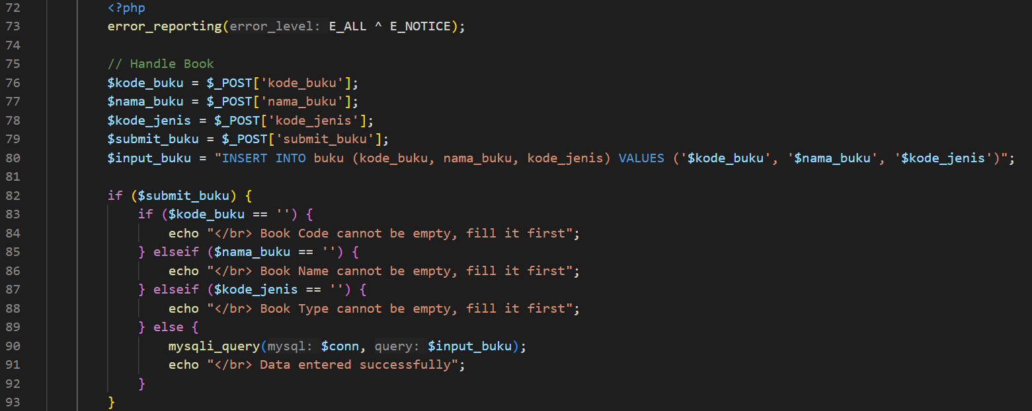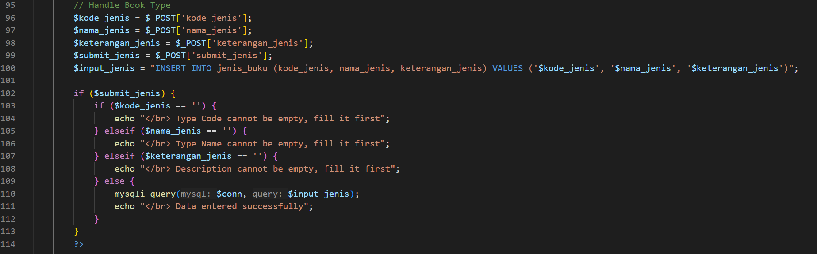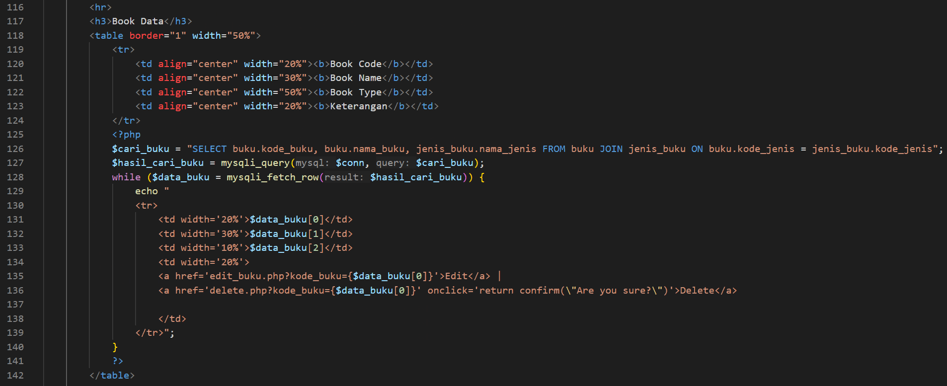

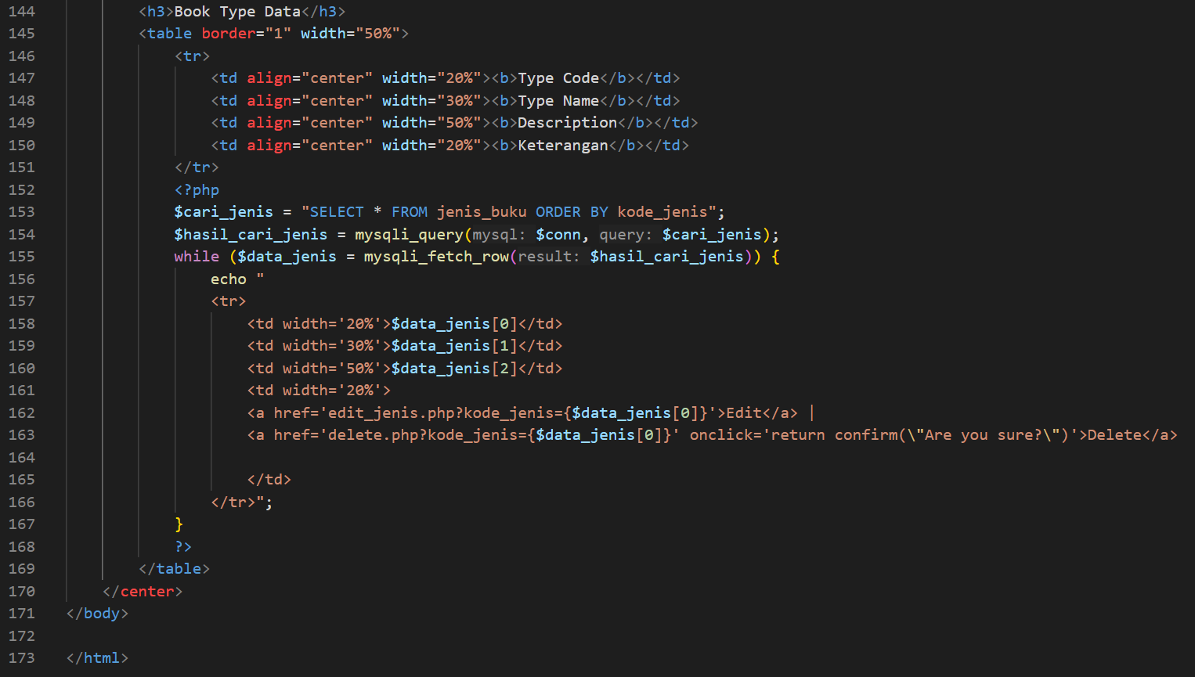

Picture 1.1. the code of form.php

1. Delete.php

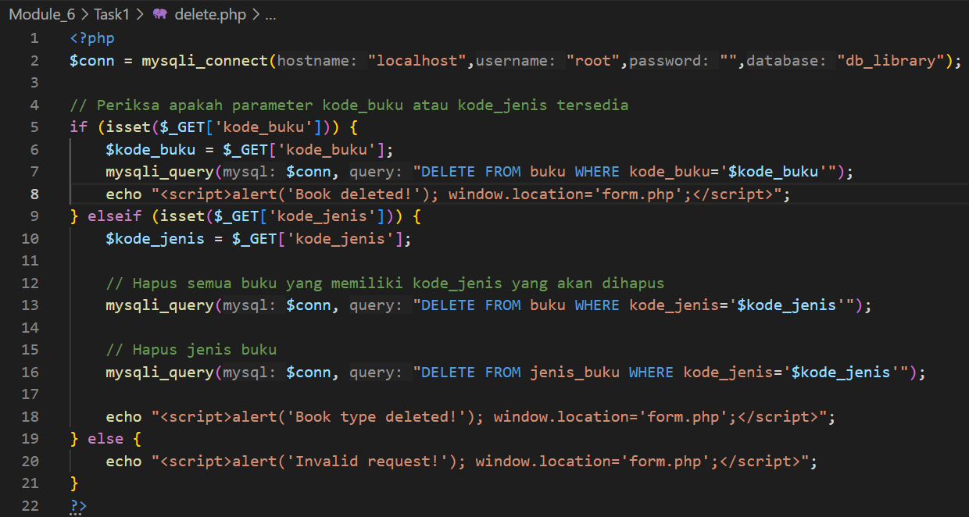

Picture 1.2. the code of delete.php

1. Edit_buku.php

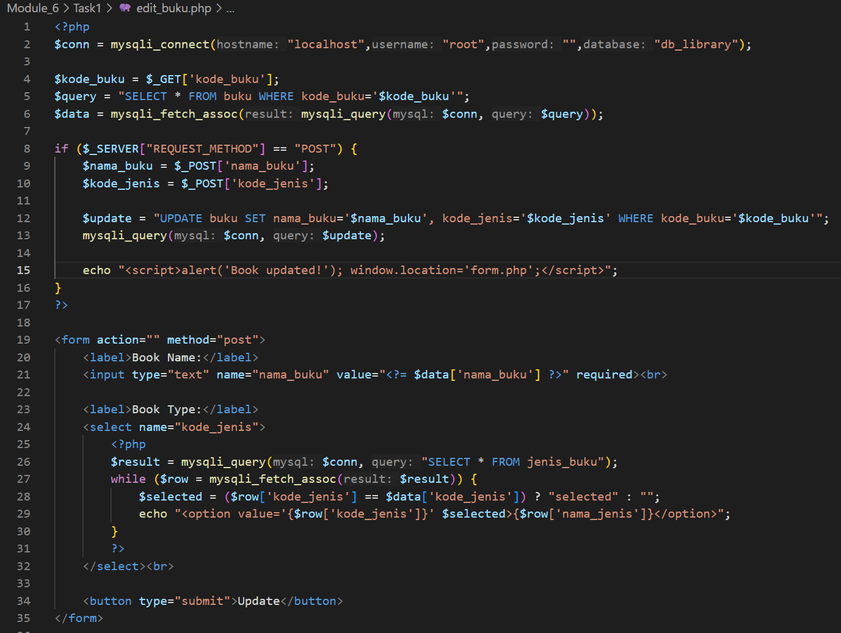

Picture 1.3. the code of edit_buku.php

1. Edit_jenis.php

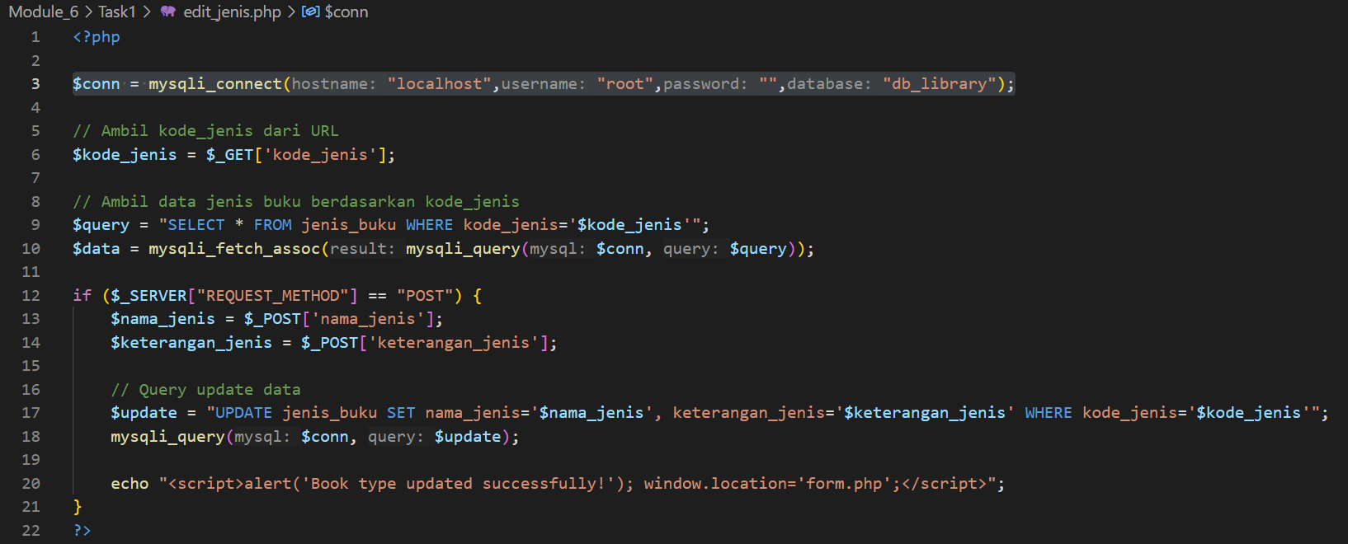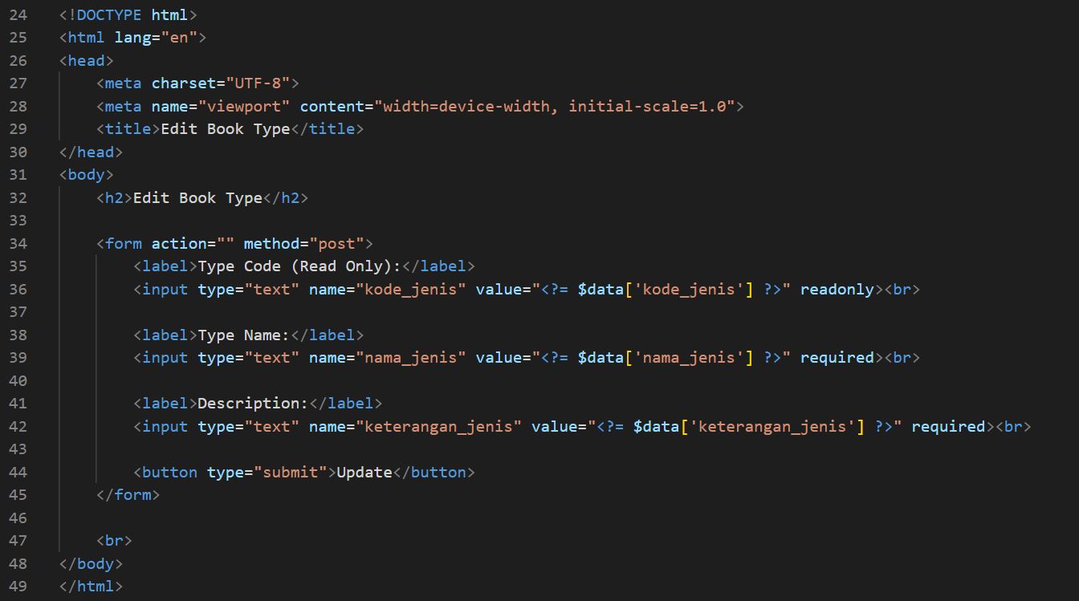

Picture 1.4. the code of edit_jenis.php

(Explanation)

1. Form.php

This code is an HTML page with PHP that connects to the `db_library` database, allows users to enter and save book data and book types through a form, with input validation before saving to the `book` and `book_type` tables, then displays a list of books and their types using SQL `JOIN`, and provides data edit and delete features.

1. Delete.php

This PHP code handles deleting data in the `db_library` database. If the `book_code` parameter is available, then books with that code are deleted from the `books` table. If the `type_code` parameter is available, all books with that type will be deleted first before deleting the book type in the `book_type` table. Once the process is complete, the page will be redirected back to `form.php` with a notification message using the `alert()` JavaScript.

1. Edit_buku.php

This PHP code allows users to edit book data based on the `book_code` received via the URL parameter. The book data to be edited is retrieved from the database and displayed in the form with the corresponding initial value. After the user edits and submits the form, the system updates the `books` table with the new data, then displays a notification using JavaScript `alert()` before redirecting back to `form.php`.

1. Edit_jenis.php

This PHP code allows the user to edit the book type based on the `type_code` received through the URL. The book type data to be edited is retrieved from the database and displayed in the form with the corresponding initial value. After the user edits and submits the form, the system updates the `book_type` table with the new data, then displays a notification using JavaScript `alert()` before redirecting back to `form.php`.

(Screenshot Output)

1. Form.php

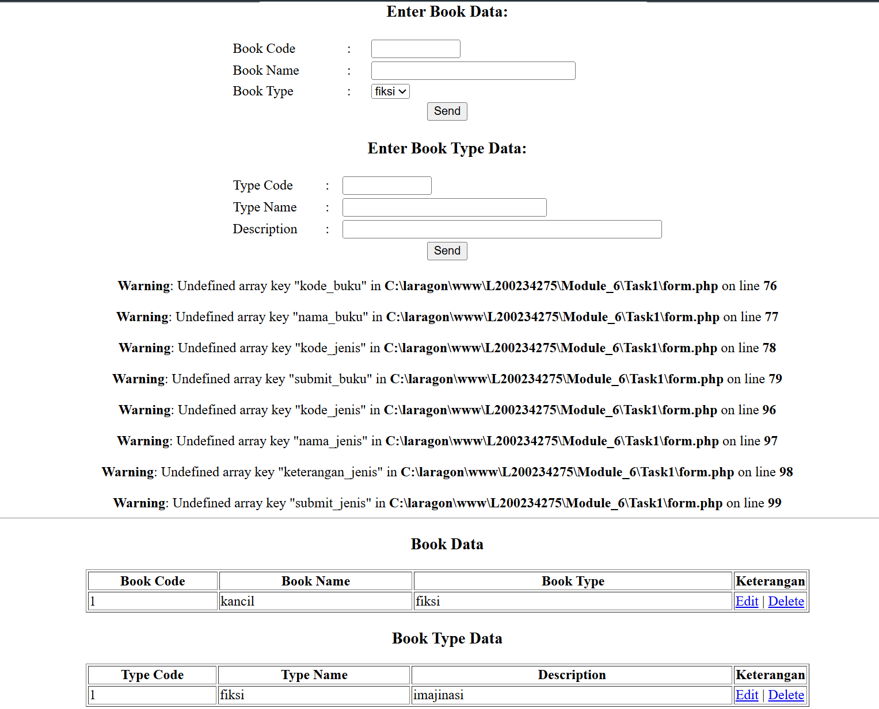

Picture 1.1 the output of form.php

1. Edit_buku.php

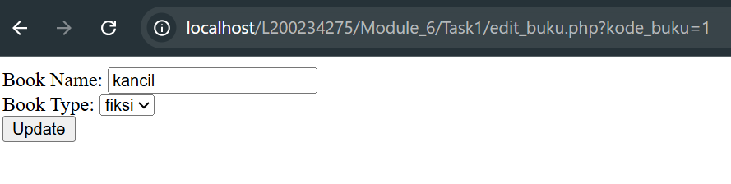

Picture 1.2 the output of edit_buku.php

1. Edit_jenis.php

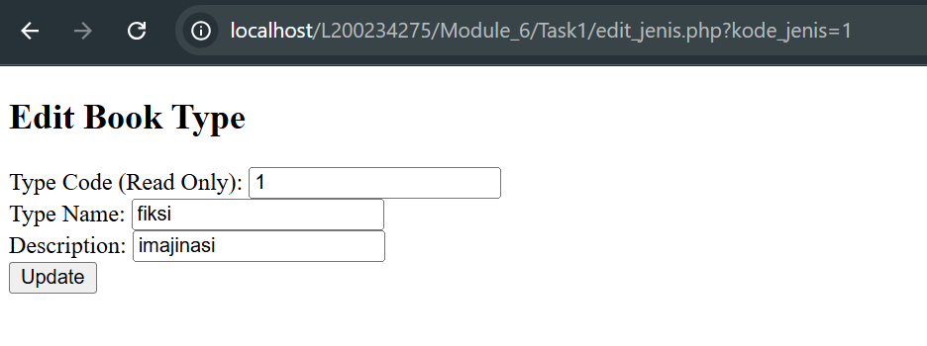

Picture 1.3 the output of edit_jenis.php